Insert your centre number, name and candidate number into the header above.
Save this evidence document as evidence_ followed by your centre number_ candidate number. For example: evidence_ zz999_9999
Screenshots or program listings must be copied into appropriate cells in the following table.
Examiners must be able to read the contents including any screenshots without the use of a magnifying glass. Answers that are not readable or missing will not be awarded any marks.
Save this evidence document at regular intervals, for example every 10 minutes.
Question 1
Part 1(a)
{Copy and paste the program code listing for Question 1(a) here}

StackData = [0 for i in range(10)] # an 1D array with 10 elements, type integer
StackPointer = 0 # Initialised to 0

Part 1(b)
{Copy and paste the program code listing for Question 1(b) here}

def outputElements():
global StackData,StackPointer
for data in StackData:
print(data)
print(f"The value of StackPointer is {StackPointer}")
outputElements()

Part 1(c)
{Copy and paste the program code listing for Question 1(c) here}

def Push(num):
global StackPointer, StackData
if StackPointer > 9:
return False
StackData[StackPointer] = num
StackPointer += 1
return True

Part 1(d)(i)
{Copy and paste the program code listing for Question 1(d)(i) here}

for i in range(11):
val = int(input("Please input a number to add"))
if Push(val):
print("Successfully added")
else:
print("Failed to add")

outputElements()

Part 1(d)(ii)
{Copy and paste the screenshot for Question 1(d)(ii) here}

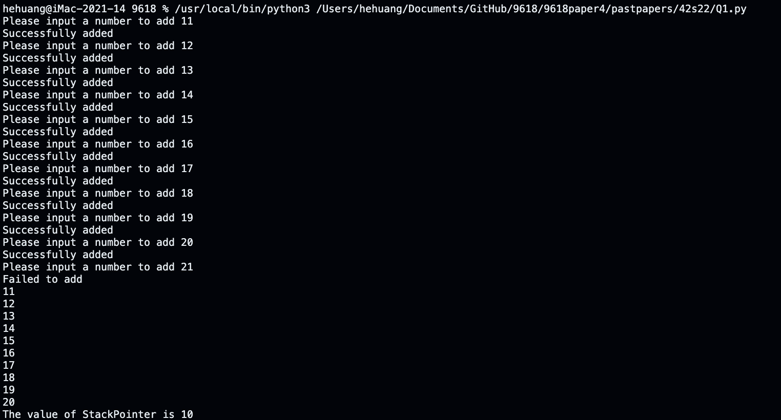

Part 1(e)(i)
{Copy and paste the program code listing for Question 1(e)(i) here}

def Pop(): # 1e
global StackPointer, StackData
if StackPointer < 0:
return -1
StackData[StackPointer-1] = 0
StackPointer -= 1
return StackData[StackPointer-1]

Part 1(e)(ii)
{Copy and paste the screenshot for Question 1(e)(ii) here}

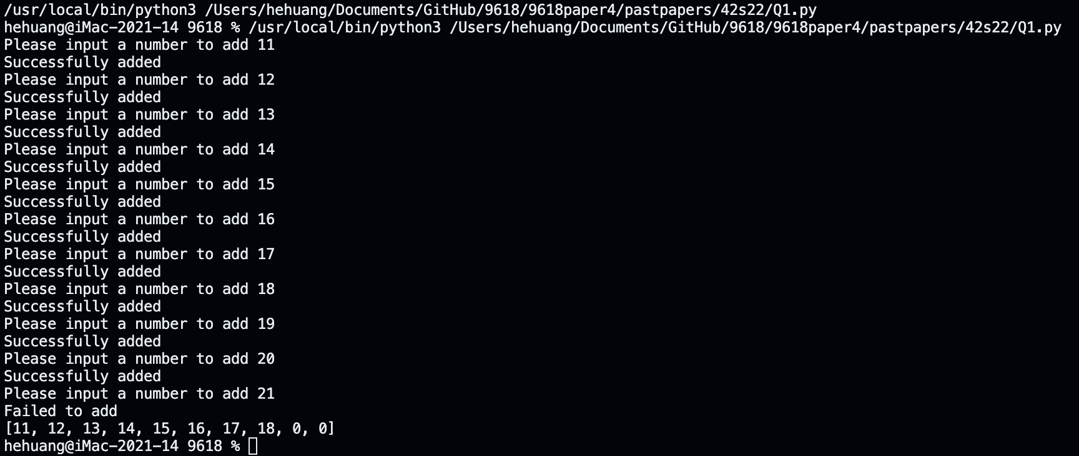

Question 2
Part 2(a)
{Copy and paste the program code listing for Question 2(a) here}

Part 2(b)(i)
{Copy and paste the program code listing for Question 2(b)(i) here}

Part 2(b)(ii)
{Copy and paste the program code listing for Question 2(b)(ii) here}

Part 2(b)(iii)
{Copy and paste the screenshot for Question 2(b)(iii) here}

Part 2(c)(i)
{Copy and paste the program code listing for Question 2(c)(i) here}

Part 2(c)(ii)
{Copy and paste the screenshot for Question 2(c)(ii) here}

Question 3
Part 3(a)
{Copy and paste the program code listing for Question 3(a) here}

Part 3(b)
{Copy and paste the program code listing for Question 3(b) here}

Part 3(c)
{Copy and paste the program code listing for Question 3(c) here}

Part 3(d)
{Copy and paste the program code listing for Question 3(d) here}

Part 3(e)(i)
{Copy and paste the program code listing for Question 3(e)(i) here}

Part 3(e)(ii)
{Copy and paste the screenshot for Question 3(e)(ii) here}

